Hyperline
Introduction
For millenniums your people looked toward the glowing orb in the center of the galaxy. Legend tells that this radiant sphere was once the homeworld of the Ancients—a race so powerful that they commanded the space between stars.
Now your scientists have discovered that the legends were true. The sphere is Nexxus, birthplace of the Ancients and gateway to all points in the galaxy. You have been chosen to lead your people out to Nexxus. But first you must master the mysterious Hyperlines.

Goal
Build and command a mighty starship as you travel the Hyperlines to Nexxus. While at Nexxus, you must research the Ancient’s technology. Each time you perform this action you gain 1 research point.
Be the first Commander to accumulate 5 research points and you will unlock the mysteries of Nexxus and win the game.
Players
2-4 players. Each player sits near one corner of the board.
Components

Board
- A 9x9 outer edge surrounding a 7x7 inner grid representing unexplored space. At the center of the galaxy is Nexxus. Each player begins the game in one of the four corners.

Planets
- 8 Silver Home Planets. You start the game on one of these planets. Each player randomly draws one and places it in his or her corner of the board.
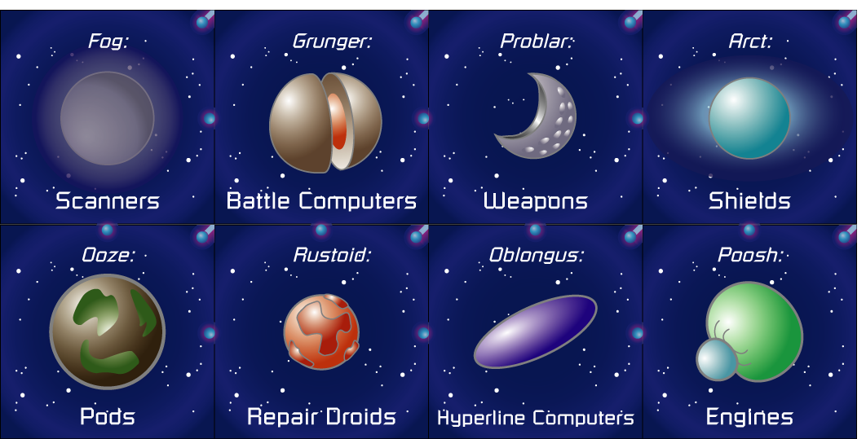
- 13 Red Tech Planets. These planets contain technologies you can buy for your ship. As the game progresses Tech planets are revealed and placed on the board.
- 1 Nexxus Planet. Placed in the middle of the board. Travel to Nexxus to research its mysteries.
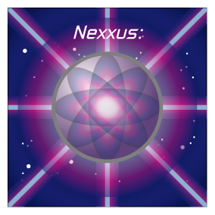

Hyperlines
- 26 Blue Hyperline tiles. These tiles connect together to form “highways” through space. As the game progresses the Hyperlines are revealed and placed on the board, forming connections from one sector of the galaxy to another. Your ship enters a Hyperpoint and follows the entire length of the Hyperline until it exits at the next Hyperpoint.
- 2 Rip tiles. These represent a huge rip in the fabric of space. A player may enter one Rip and travel to the other for free.
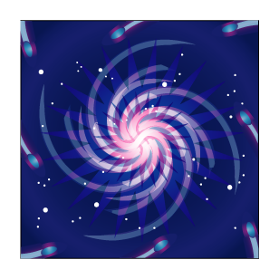

Hazards
- 3 Red Asteroid tiles. Huge fields of floating rock that can slow you down and damage your ship. The Asteroids are shuffled into the Planet Stack.
- 4 Blue Pirate Bases. Hidden throughout the galaxy are the lairs of the Space Pirates. They will always fight when encountered. The Pirate Bases are shuffled into the Hyperline Stack.

Starship and Fightercraft Tokens
- 4 Starships (1 per player). This token represents your main ship.
- 32 Fightercraft (8 per player). Fighters can be used to patrol a sector or can be loaded onto your Starship.

Pirate Ship Tokens
- 12 black spaceship tokens that represent the evil Space Pirates. These are divided into three strengths: small Pirate Fighters (Level 1), medium-sized Pirate Cruisers (Level 2), and large Pirate Battleships (Level 3).
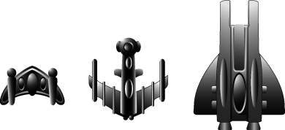

Tech Tokens
- 20 small cardboard tokens (5 tokens of a matching color for each player). Whenever you buy a component you must pay for it with one of these.
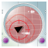


Starship Components
These tiles represent different Starship systems. By attaching components together you create a unique Starship. Each component has two sides: functional and damaged. It should be obvious which side is which.
- 4 Bridge components (1 per player). The command module of your ship.
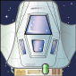
- 24 Pods. Can hold fighters, turrets or battle systems.
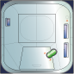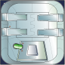
- 24 Engines. Moves your ship around the galaxy and maneuvers during combat.
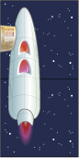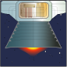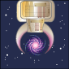
- 24 Weapons. For close and long range combat.
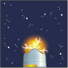
- 24 Shields. Prevents damage to your ship.

- 24 Scanners. Explore the galaxy from a safe distance and boost your research.


Bridge Upgrades

Each Bridge upgrade has two sides: online and offline. It should be obvious which side is which.
- 4 Repair Droids (1 per player). Repairs damaged components.

- 4 Battle Computers (1 per player). Gain a decisive first strike on your opponent (or run away before the battle begins).
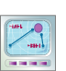
- 4 Hyperline Computers (1 per player). Calculates connections through diagonal Hyperpoints.

Research Points
- 20 glass beads. Each time you successfully perform the Research Command you gain 1 research point. Collect 5 to win the game.

Dice
- Four 4-sided dice (1 per player).

Quick Guides
- Two reference guides showing the Turn Order and listing the abilities of all the components
Setup

Place Board
Place the board in the middle of the table. Each player sits near one corner of the board and should note their color. In a two player game players may choose to sit diagonally opposite each other (for a game with a longer build-up) or may start along a shared side (for a more aggressive early game).
Place the Nexxus tile in the center of the board.

Sort Ship Components
Create a “Store” of components off to one side of the board. Organize the components into 5 major sections: Pods, Engines, Weapons, Shields and Scanners. Each major section will contain 3 piles of 8 matching components.

Shuffle Planet and Asteroid Tiles
Place the 13 Tech Planets and the 3 Asteroid tiles face down. Mix them up and stack them in one pile. This is called the Planet Stack. All the planet tiles have red backs.

Shuffle Hyperline and Pirate Tiles
One of the Hyperline tiles has a Rip image on both sides. Place this tile aside until it is needed later in the game.
Mix the remaining 27 Hyperline tiles together with the 4 Pirate tiles and place them facedown into a Hyperline Stack. All the Hyperline tiles have blue backs.

Draw a Home Planet
Turn the 8 Home Planet tiles (silver backs) facedown and mix them up. Each player draws one and places it in the corner nearest them. The remaining Home Planet tiles will not be used this game.
If there are less than 4 players then some of the corners will be empty. These corners are considered neutral planets and have no special features.

Take Starting Pieces
Select the pieces that match your corner’s color. Each player takes:
- A 4-sided die.
- 1 Starship token. Place this on your Home planet.
- 1 Repair Droid, 1 Hyperline Computer and 1 Battle Computer token.
- 5 Tech tokens. 1 Pod, 1 Engine, 1 Weapon, 1 Shield and 1 Scanner token. These are used for purchasing components on Tech Planets.
- 8 Fightercraft. Place the fighters into the eight small squares along the corner of the board.

Build Your Ship
Take one Bridge component and put in it front you. Select one Pod and one Engine of your choice from the Store. Connect all three components together to form your starting ship.
Your Bridge must always face toward the front of your ship and have a Pod connected directly behind it. Hyperline and Combat Engines must face toward the rear. Below are two typical starting ship configurations (others are possible):
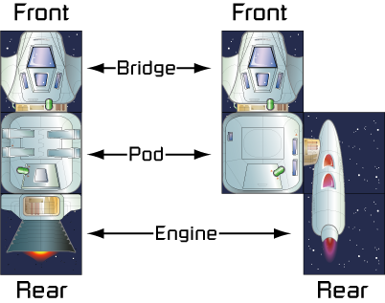

Choose Bonus Component
Each player starts with one bonus component, based on the technology offered by their Home planet. Choose a component that matches your Home tech and connect it to your Starship.
If you are building a Pod, Engine, Weapon, Shield or Scanner your must “pay” for it by placing your matching Tech token onto your Home planet sector. (See Tech Tokens on page 5.)
If you are building a Bridge upgrade (Repair Droid, Hyperline Computer or Battle Computer) then you do not need to place a Tech token.

Determine First Player
Roll your die. The player rolling the highest number goes first.
Overview: A Player’s Turn
During your turn you follow these 5 phases in sequence. Some phases may not apply during your turn and can be skipped.

1. Hyper-radiation Damage
If you start your turn in the Nexxus sector then your ship takes 1 damage. You choose which ship component to damage.

2. Scan
Each Scanner on your ship may make 1 scan.

3. Ship Command
You may choose one of these four actions:
a) Build
If you are in a sector with a Tech planet then you may take one component of the appropriate type from the Store and connect it to your ship.
You may reconfigure your ship by moving your components into new positions.
b) Repair
Flip one damaged component over, restoring its functionality.
If you are on your Home planet you may flip over all of your damaged components, restoring your entire ship back to full functionality.
c) Move
Pick up or drop off fighters. Each Carrier Pod can load 1 Fightercraft.
Either Step (move to an adjacent, non-diagonal sector) or Jump (enter a Hyperpoint and travel along a Hyperline until you exit at the next Hyperpoint).
If you are about to enter an unexplored sector then draw a tile and place it into the sector as you move into it.
d) Research
If you are in the Nexxus sector you first damage one component of your choice. If your Bridge is still functional then collect 1 research point.
Scanners can be used to collect a second bonus research point.

4. Combat
If your Starship or fighters are in a sector with another player’s ship and/or fighters you may choose to fight.
If your Starship or fighters are in a sector with a Space Pirate you must fight.
Combat is fought in a series of Combat Rounds. Each round has 6 steps that must be followed in order. Combat lasts at least 1 round and continues up to a maximum of 3 rounds. Combat can be cut short if one of the participants decides to run away.
Combat Round Steps

1. Roll Direction Die
This roll determines which quadrant the enemy is in.

2. Give Damage (simultaneously)
Fire weapons at enemy ship.

3. Take Damage (simultaneously)
Take damage from enemy ship.

4. Battle Pod Shields Recharge
All Shields attached to Battle Pods recharge, except if the battle is at Nexxus.

5. Run Away
First the attacker, then the defender, may choose to run away and end the Combat phase.
Space Pirates never run away from battle.

6. Continue to Next Round (maximum of 3)
Go back to step 1.

5. Shields Recharge
Shields do not recharge while on Nexxus.
All other players may flip their damaged shields back up to the charged state.
All Space Pirates return to full strength.

End of turn
The player to your left starts the next turn.
Ending the game
The game ends when a player collects 5 research points. You can only collect research points while orbiting Nexxus with a functional Bridge.
Detailed Rules
Phase 1. Hyper-radiation Damage
Skip this phase if you are not on Nexxus.
Nexxus is a dangerous place. If your Starship starts the turn on Nexxus you must immediately assign 1 damage to it. You may choose any component to damage.
To damage a piece simply flip a functional component over to its damaged side. (See Taking Damage on page 9.)
All of your unprotected fighters are destroyed. Fighters loaded into a Carrier Pod are protected. (See Carrier Pods on page 15 for more details.)
Phase 2. Scan
Skip this phase if you have no Scanners.
Each Scanner on your ship may make 1 scan.

To perform a normal scan, select a Scanner on your ship, then point to an unexplored, connected sector on the board. (See Connections on page 18.)
Take the top tile from the Hyperline stack, reveal it and place it in the chosen sector. (You may not choose a Planet tile when doing a normal scan).
You may rotate the tile in any direction you choose as you place it.
Instead of making a normal scan, each Scanner type has a special ability that allows it to make a special type of scan. (See the Scanner section on page 17 for more details.)
Phase 3. Ship Command
This is the main phase of your turn. You may choose one of these four commands (or pass, if you wish):

a) Build Command
Your Starship begins the game with a few basic components, but if you have aspirations of controlling the galaxy then you will need to expand your ship’s capabilities.
If you are in a sector with a Tech planet you may purchase a component of the appropriate type. Select your desired component from the Store and connect it to your ship. For example, if you are on the Shield planet Friskus then you may purchase a Hardpoint Shield, an Interphasic Shield or a Transfer Shield.
There are only 8 components of each type. Once they are purchased you may not buy any more components of that type. (First come, first served.)
Tech Tokens
Each player has 5 Tech tokens, one for each type of technology:
Whenever you buy a component you must pay for it by placing your matching Tech token on the planet. For instance, before buying a Shield from Friskus, you must first place your Shield Tech token in the Friskus sector.
You cannot buy a component from a planet that already has one of your Tech tokens on it. This prevents players from “camping” on a planet and loading up on components of the same type.
You can move your Tech token off of one planet to pay for a similar component on another planet. For instance, you could take your Shield Tech token off of Friskus and use it to purchase another Shield from Ophasic.
Your Tech tokens do not affect other players’ Tech tokens. A planet may have any number of matching Tech tokens on it at the same time.
Placing Components
Each component must be attached to your Starship in a legal configuration. In general, most components must be connected to a Pod or to your Bridge. And your Starship tiles must align in a grid and not overlap each other. However, a few components have different restrictions, so refer to the Ship Components section (page 15) for details on a specific component.
- You can connect to damaged components.
- You may not buy a component if it cannot legally connect to your Starship.
- There is no limit to the size your Starship can grow (other than running out of new components to buy in the Store). As long as you can find ways to make new components fit on your ship then you can keep purchasing them.
Bridge Upgrades
Six planets—Y-Bot and Rustoid (Repair Droids), Hycom and Oblongus (Hyperline Computers), and Viper and Grunger (Battle Computers)—sell Bridge upgrades. Like the name suggests, Bridge upgrades are a special type of component that enhance your Bridge.
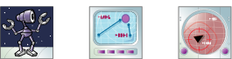
You start the game with 3 Bridge upgrade tokens in front of you (1 Repair Droid, 1 Hyperline Computer and 1 Battle Computer). When you purchase a Bridge upgrade take the matching token and place it on top of your Bridge tile. It stays on your Bridge for the rest of the game.
- You may not buy multiple copies of the same Bridge upgrade.
- You may buy a Bridge upgrade even if your Bridge is damaged. In this case the newly acquired upgrade is placed on your Bridge in its offline state.
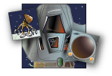
- There are no Tech tokens for Bridge upgrades.
Reconfiguring
Whenever you perform a Build command you may reconfigure your Starship by moving around any number of your components to new, valid locations. This is the only time you may rearrange your Starship’s configuration.
You may perform the Build action just to reconfigure your ship. In this case you do not need to purchase a new component. However, you must still be in a sector with a Tech planet; you cannot reconfigure your ship in a Hyperline, Asteroid, or empty sector. In addition, you may not reconfigure while on Nexxus or on another player’s Home planet.

b) Repair Command
As you travel through the galaxy your Starship will face many hazards and obstacles and may become damaged. A good Commander knows when to press onward and when to stop for repairs.
You may perform the Repair command on any sector on the board, except on another player’s Home planet.
Standard Repair
Flip one damaged component over to its functional side. This restores that component back to working condition.
The component must stay in the same location on your Starship. If you want to move a component to a new location you must use the Build command (see Reconfiguring, above).
Home Planet Repair
If you are on your Home planet you may flip over all of your damaged components, restoring your entire ship back to full functionality in one turn.
Repair Droids
Repair Droids are a type of Bridge upgrade that can assist with the standard Repair command. They cannot assist with a Home Planet Repair. They cannot repair while on Nexxus.
If you perform a standard Repair command while you have an online Repair Droid then you may perform an additional non-Repair command in the same turn. For instance, you may repair an Engine and then move in the same turn.
(See Repair Droids, page 15 for more information.)
Bridge Damage and Repairs
If your Bridge is damaged then all of your Bridge upgrades immediately go offline. Flip them over to their offline side but keep them on your Bridge tile. When your Bridge is repaired flip the upgrades back to their online side.

c) Move Command
Before your Starship can leave your Home planet you must first understand the Hyperlines—mysterious pathways that allow instantaneous passage between two sectors of the galaxy. Each time you travel via a Hyperline it is called a Jump.
Sometimes the lines won’t be in your favor. In this case you can plow through space “the old-fashioned way”: one sector at a time. This type of movement is called a Step.
Before you move your Starship you must first declare the type of move you are making—a Jump or a Step—and then declare your destination sector. If you are Jumping then your destination must be connected to you. If you are Stepping then your destination must be adjacent. (See Connected and Adjacent Sectors on page 18).
- If your destination sector is unexplored then you must explore it (see below).
- After your destination has been explored (or if it was already explored) then you move your Starship token into the destination sector.
Exploring
Whenever your Starship attempts to move into an unexplored sector you immediately draw a tile and place it face up in that sector.
You may rotate the tile in any orientation.
- Normally, a planet cannot be placed adjacent to another planet. If you are exploring a sector that is adjacent to a Planet sector then you must draw your tile from the Hyperline stack. However, if the Hyperline stack is empty you draw from the Planet stack instead.
- If you are exploring a sector that is not adjacent to a planet then you may draw from either the Hyperline stack or from the Planet stack. Asteroids are not planets.
After you finish exploring a sector you must immediately move into it. You cannot decide to go somewhere else instead. (If you want to know what’s in a sector before moving into it then use a Scanner.)
Jumping
Jumping into an unexplored Hyperline is a risky, but necessary, way to travel through the galaxy in the early phases of the game. Each blind jump is a potential rollercoaster ride to parts unknown. As the game progresses the Hyperline routes will be revealed. At that time Hyperline travel will be less about risk and more about efficient navigation.
A Hyperline is a line through the galaxy that terminates on each end with a Hyperpoint.
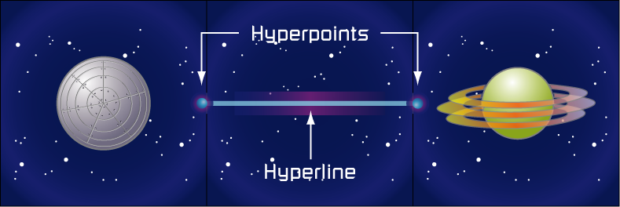
To move through a Hyperline you first announce your intention to “Jump” and select a non-diagonal Hyperpoint in your current sector. Push your Starship token onto the Hyperpoint to enter the Hyperline.
Hyperline Computers allow you to enter diagonal Hyperpoints. (See page 15 for more information on this Bridge upgrade.)
Once you enter the Hyperpoint you are committed! You must follow the entire Hyperline until you exit at another Hyperpoint or until you are blocked (see Blocking a Move on page 8).
As you make the Jump, slide your Starship token along the Hyperline. Explore (draw a new tile) if your ship is about to enter an unexplored sector. After placing the tile continue sliding along the Hyperline until it terminates. You may end up exploring many sectors before the Jump ends.
Hyperline Patterns
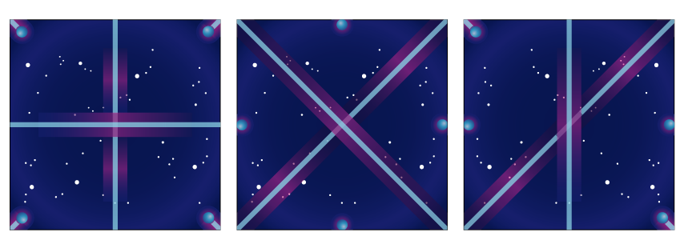
- Some Hyperlines cross over each other. You can identify these because the lines meet at an intersection with a sharp corner. You may not change your direction at such a juncture; you must continue straight along your path.
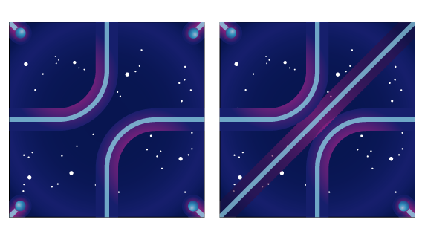
- Some Hyperlines bend. These bends are always smooth curves, never sharp corners. As you travel along a Hyperline your path bends along with the line.
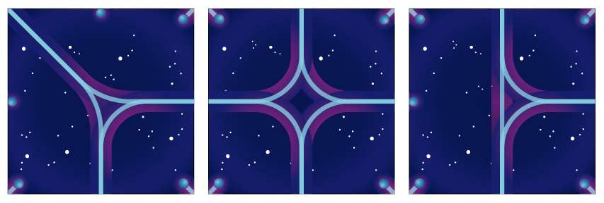
- Some Hyperlines branch off in two directions. When you reach one of these splits you must choose a direction and slide your Starship token along one path or the other.
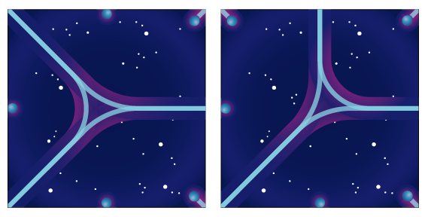
- Some lines will convert a straight (horizontal or vertical) path into a diagonal path (or vice-versa). These may act as one-way passages since you can only enter non-diagonal Hyperpoints. To get back to where you came from you will need to find a new route. (A Hyperline Computer will let you avoid this problem. See page 15.)
Stepping
Instead of traveling by Hyperline you may travel through normal space.
Declare that you are taking a “Step” and specify the destination sector. Your destination must be an adjacent (non-diagonal) sector next to your Starship.
Explore the sector (if it is not already explored) and move your Starship into it. Your move ends.
- When stepping, ignore all Hyperlines and Hyperpoints.
Loading and Unloading Fighters
Before you begin a move you may load or unload fighters. You cannot load or unload fighters while you are in the middle of a Jump.
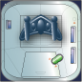
Each Carrier Pod on your Starship can carry one Fightercraft. Fighters not in your Carrier Pods are considered on patrol and cannot move along with your Starship.
Hyperline Engine Bonus
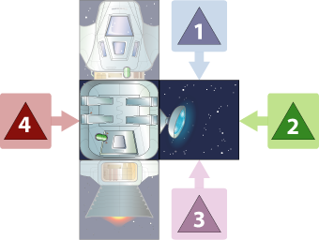
Each functional Hyperline Engine attached to your Starship gives you one bonus move. A bonus move can be used to either Jump or Step. You can make a bonus move only if you have chosen the Move command this turn. You cannot, for example, perform a Build command and then take a bonus move in the same turn.
You may load or unload fighters before each bonus move.
Blocking a Move
If you move into a sector with a Pirate, an Asteroid, an opponent’s Starship, or an opponent’s fighters, you are blocked and must immediately end your movement. This not only ends your current move, but also ends the Command phase. You cannot use a bonus move to leave a blocked sector.
Loop Lines
Four sectors in the outer edge contain Hyperlines that lead off the board. These lines are called loop lines and they connect with the loop lines on the opposite side of the board. If you travel off one side of the board you will reappear on the other side! (See Loop Lines on page 14 for more details.)

d) Research Command
The intense Hyper-radiation which emanates from Nexxus is a danger to all ships in the sector. But to unlock its secrets you will face even greater peril: you must enter a lethally close orbit around the planet itself.
You may only perform the Research command if your Starship begins its turn in the Nexxus sector. You must also have a functional Bridge.
As soon as you choose the Research command you take 1 point of damage. This damage can be applied to any component of your ship.
If your Bridge is still functional then collect 1 research point and put it near your home corner. Collect 5 research points to win the game!
Tight Scans
Normally, you may only gain 1 research point during a Research command. However, if you have at least one Scanner attached to a Battle Pod then you may attempt a tight scan to gain one bonus research point.
You may only perform one tight scan per turn and it must follow a normal Research action.
If you decide to do a tight scan then immediately take 1 damage and apply it to any component on your Starship. You take this damage whether or not the tight scan is successful.
If your Bridge is still functional then roll a direction die. If you have at least one Battle Pod enhanced Scanner facing that direction then you earn one bonus research point, otherwise you gain nothing for your efforts.
In this illustration you would need to roll a 2 to gain the bonus research point. A roll of 1 or 3 would hit the side of the Scanner, while a roll of 4 would be blocked by the Battle Pod.
If you have additional Scanners facing the same direction you do not gain additional research points. You may only gain one bonus point per Research command.
If a tight scan gives you your fifth research point then you win the game!
Phase 4. Combat
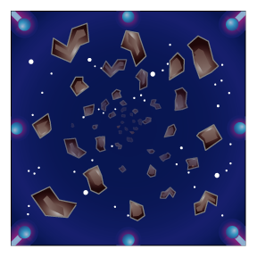
If your Starship begins the Combat phase in an Asteroid field then you first take 1 point of damage. This procedure is described in Asteroids, on page 11.
Player vs. Player
- Combat may occur in any sector where you and an opponent both have a Starship and/or fighters. The player taking the current turn decides whether to attack or not.
- You may not attack a Starship that is running away.
- If there are multiple sectors where combat could occur then the current player resolves them in any order he chooses.
- Combat is always one vs. one. If there are multiple opponents in the same sector then you pick which one to attack (if any). After you finish one battle in a sector you may not fight in that sector again until your next turn.
Player vs. Pirate
Combat must occur if your Starship and/or fighters are in a sector with Space Pirates. You must fight the Pirates, even if there are other ships in the sector.

Combat Round Steps
Combat is fought in a series of Combat Rounds. Each round has 6 steps that are followed in order. Combat lasts at least 1 round and continues up to a maximum of 3 rounds. Combat can be cut short if one of the participants decides to run away.
A player with a Battle Computer can run away before the battle begins. (See Battle Computer on page 15.)
1) Roll Direction Die
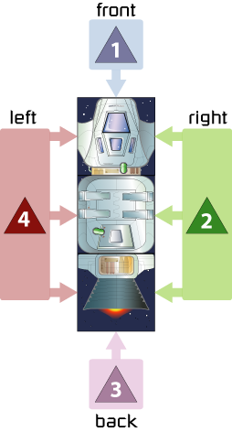
Each player participating in the battle rolls a 4-sided die. Pirates do not roll. If your speed is greater than your opponents you can modify your roll. (See Combat Engines on page 16.)
This roll determines which quadrant the enemy is in, relative to your position. On a roll of 1 the enemy is attacking you from the front, a 2 means the enemy is attacking from the right, a 3 from the back and a 4 from the left.
After you roll, place your die in the appropriate quadrant as a visual reminder.
Players often end up attacking each other from different directions. In the example below, Bob is fighting Jim. Bob rolls a 1, which means Jim’s ship is attacking him from the front. Jim rolls a 3, which means Bob’s ship is coming in from behind. Their relative positions look like this:
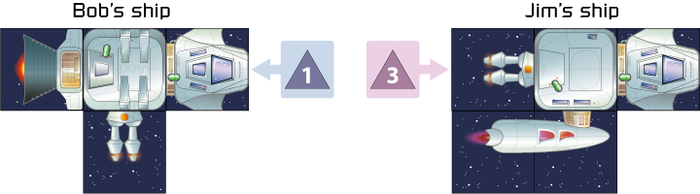
Bob is out of luck this Combat Round. His weapons are pointing the wrong way and he will soon be eating lasers from Jim’s rear guns.
For your first few battles you may find it helpful to position the Starship tokens on the board in the correct combat orientation. This will help you visualize how the two ships are engaged.
2) Give Damage
Both players add up the strength of all of the weapons facing the enemy plus 1 extra point for each of your fighters in the sector (loaded and on patrol). This is the amount of damage the enemy must take in the next step.
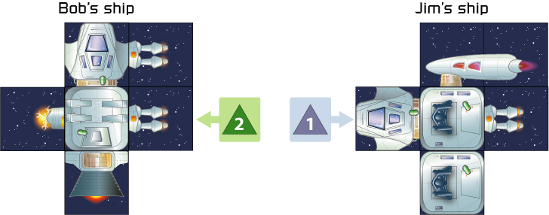
In the illustration above, Bob has rolled a 2, which means his right side is toward Jim. Jim has rolled a 1, which points his nose at Bob’s ship. Bob gives Jim 3 damage (2 for the Battle Pod Laser Cannon + 1 for the Bridge Laser Cannon). Jim gives Bob 2 damage (1 for each fighter). Note that Bob’s Plasma Launcher and Jim’s Laser Cannon are both facing the wrong way and don’t contribute any strength to this attack.
- Pirates do damage equal to their ship’s level.
- Both players give out damage simultaneously.
3) Take Damage
One component must be damaged for each point of damage you received.
One by one, you select which components are damaged on your ship. The selected components must not be blocked by other functional components.
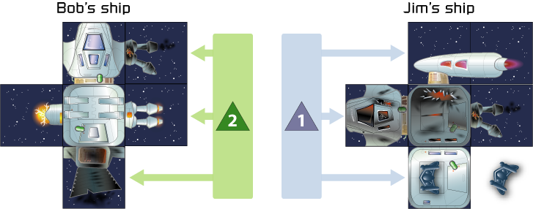
Continuing the battle from above, Bob must take 2 damage. For his first point of damage he selects his Combat Engine. He flips over that piece then takes his second point of damage to his Bridge Laser.
Jim must take 3 damage. He takes the first point to his Bridge, his second to his Carrier Pod (which ejects his fighter out to patrol status), and his third to his Laser Cannon. Note that he could not have taken damage to his Carrier Pod until his Bridge was damaged, because functional components block the components behind them. Likewise, he could not have damaged his Laser Cannon until his Carrier Pod was damaged.

Fighters can always take damage, no matter which direction your ship is facing. Fighters are never blocked by functional components. A fighter is destroyed if it takes 1 point of damage and is removed from the game.
Important: If all of your components are damaged and all your fighters in the sector are destroyed and you still have damage points to assign then you must run away in Step 5.
Pirates are destroyed if they take damage equal or greater than their ship’s level. (See Space Pirates on page 12.)
Normally, players take damage simultaneously. However, a Battle Computer (see page 15) gives you “first strike”; your enemy takes your damage before he gives you any damage.
A Focus Beam (see page 16) gives you the ability to target a specific component on your enemy’s ship. You, not your opponent, get to pick the component to damage.
4) Battle Pod Shields Recharge
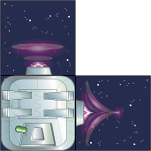
Skip this step if you are on Nexxus. Shields do not automatically recharge on Nexxus.
All Shields attached to functional Battle Pods recharge. Flip them over from the damaged side back to the functional side.
5) Run Away
The Attacker can decide if he would like to run away. If so, the Combat phase is over.
If the Attacker doesn’t retreat then the Defender has the option to run away. If so, the Combat phase is over.
Important: If you run away then you must perform a Move command during your next Ship Command phase. Tip your Starship token over onto its side as a visual reminder. On your next turn declare the Move command and stand your Starship token upright again.
- Starships that are running away cannot be attacked. Running away from one opponent protects you from all other opponents who may be out to get you.
- Fighters on patrol can run away from a battle. However they are not forced to leave the sector on the next turn, since fighters can only move if loaded onto a Carrier Pod.
- Space Pirates never run away from battle.
6) Continue to Next Round
If this is the third round of Combat then the Combat phase is over. Combat always ends after the third round, even if neither player has retreated.
If this is the end of the first or second round, and neither player has run away, then start a new Combat Round by going back to the Roll Direction Die step.
Phase 5. Shields Recharge
This final phase affects all players, not just the current player.
All players not at Nexxus may flip all damaged shields back up to the charged state. (The intense Hyper-radiation at Nexxus prevents Shields from recharging there.)
All damaged Space Pirates return to full strength.
This ends the current player’s turn. Play passes to the next player to the left. Continue through this turn sequence until a player collects 5 research points.

Other Rules
Home Planets
Each player starts the game by randomly selecting a tile from the Home Planet stack. Unused Home Planet tiles are removed from the game.
Place your Home Planet tile in your corner of the board.
Before the game begins you may purchase one component of the appropriate type from your Home planet and attach it to your Starship. If you are buying a Pod, Engine, Weapon, Shield or Scanner then you must pay for it by placing the matching Tech token on your Home planet. (See Tech Tokens, page 5.)
Your Home planet is a safety zone. Other players can enter the sector, but they cannot perform the Build or Repair command while there. In addition they may not initiate a Combat while there. Of course, you are free to attack them during your Combat phase!
Your Home planet starts the game defended by 8 fighters on patrol. (See Patrols on page 13.)
Rip Sectors
There are two Rip tiles in the game. One is printed on both sides and is set aside when the game starts. The other is shuffled into the Hyperline stack.
When a player explores the Rip he or she immediately places the other Rip tile in any empty sector on the board. Once the Rips are placed they may not be moved again.
- Any player ending a Move on a Rip sector may immediately move to the other Rip sector for free. This is considered a bonus move
- Rip sectors are not considered Planets. You may place a Rip next to any Planet, including Nexxus.
A Rip Engine is a component that allows you to move to a Rip sector from anywhere on the board. (See Rip Engines on page 16 for more details.)
Asteroid Fields
There are 3 Asteroid fields in the Planet stack. Even though they are shuffled with the planets they are not considered planets when placed on the board.
If your Starship begins the Combat phase in an Asteroid field you take 1 damage from the Asteroids.
Roll a direction die to determine which direction the Asteroid strikes. Asteroids have a speed of 0, so you may modify this roll if you have Combat Engines (see page 16).
Use the normal damage rules when choosing which component to damage. However, you cannot assign Asteroid damage to your fighters (they are too nimble).
Pirates and fighters never take Asteroid damage.
A Battle Computer Bridge upgrade lets you treat Asteroid field tiles as if they were blank tiles. (See page 15 for details.)
Pirate Bases
There are 4 Pirate Bases in the Hyperline stack.
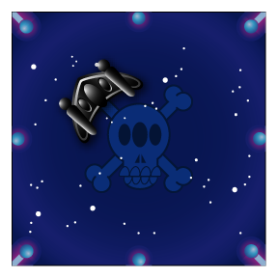
- When a Pirate Base is explored place a Level 1 Pirate ship on the base. The first player to enter that sector must fight the Level 1 Pirate
- Pirates may be destroyed. When this happens the Pirate Base will be empty. Treat these sectors as featureless patches of space with no special properties.
Space Pirates
Whenever you enter a sector with a Pirate you are blocked and must immediately end your Command phase. Proceed to the Combat phase of your turn.
Space Pirates have no components on their ships, they simply have a Level, from 1 to 3. The higher the level the tougher the Pirate. The level number represents the Pirate’s weapon strength, its total number of hit points, and its speed.
When fighting a Pirate the rules of combat are slightly modified, as described below.
Direction Die
Pirates don’t have a facing and don’t roll a direction die. However, you must still roll a direction die when fighting them to determine the quadrant they attack from.
Pirates have a speed rating equal to their Level. For example, a Level 2 Pirate has a speed of 2. If your speed is faster than the Pirates then you may modify your die roll. (Pirates don’t have a direction die so they have nothing to modify, even if their speed is greater than yours.)
Giving Damage
Each Combat Round a Pirate gives damage equal to its level. For example, a Level 3 Pirate gives 3 damage per round. (That’s a maximum of 9 damage if the combat were to last the full three rounds!) Pirates always give out their full damage each Combat Round, even if they were damaged in a previous round.
Taking Damage
When a Pirate takes damage equal or greater than its level it is destroyed and combat immediately ends. For example, it only takes one hit to destroy a Level 1 Pirate.
Damage to Pirates is cumulative during one Combat phase. For example, you can destroy a Level 3 Pirate by doing 1 damage to it during each of the 3 Combat Rounds. If a Pirate is not destroyed it is automatically “repaired” back to full strength during the Shields Recharge phase.
Aggravating the Pirates
Whenever you destroy a Pirate ship you make the Space Pirates more aggressive. The player who destroys a Pirate immediately places a new Pirate in any unoccupied sector on the board, except for Home planets and Nexxus. The new Pirate is one level higher than the destroyed Pirate.
- The strongest Pirate is Level 3. If a Level 3 Pirate is destroyed you place a Level 3 Pirate instead.
- You may place a Pirate in an unexplored sector (one without a tile). If you do this then make sure you clearly specify which sector contains the Pirate.
- Once placed, a Pirate may never move out of its sector. If you are unhappy with the location of Pirate then you must destroy it to get it out of the way.
Running Away
Pirates never run away from you; they will fight to the death. But you are free to retreat from them during the Run Away step.
Performing Commands
You may perform a Repair or Build command while in a sector with a Pirate. (Keep in mind that if you choose either of these commands you will be fighting them in upcoming Combat phase.)
If you start your Command phase in the same sector as a Pirate you can use a Move command to leave. However, you may not use a bonus move to leave the sector. (See Hyperline Engine Bonus on page 8.)
Fighters
You start the game with 8 fighters protecting your Home planet. If your Starship has Carrier Pods it can pick up your fighters and transport them to other sectors. Fighters are either considered loaded or on patrol. Fighters that are loaded must be placed on a Carrier Pod. Fighters on patrol are placed in a sector on the board.
Fighter Combat
Fighters in a sector without a friendly Starship have a speed of 3, but have no facing so they do not need to roll a direction die.
Fighters in a sector with a Starship (whether loaded or on patrol) are considered part of that Starship and use its direction die roll and match its speed.
During each Combat Round every fighter in the sector (whether loaded or on patrol) attacks for 1 damage, regardless of your Starship’s facing.
When you take damage you can assign it to any of your fighters in the sector, regardless of your Starship’s facing. A fighter is destroyed if it takes 1 damage. Destroyed fighters are removed from the game and can never be repaired.
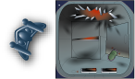
When a Carrier Pod is damaged it does not damage a loaded fighter. Instead, the fighter is placed on the board and is considered to be on patrol.
Patrols
A fighter can be left behind to patrol a sector. Patrols can be used to defend a sector and block your opponent’s moves.
- Pirates cannot be placed in sectors with patrols.
- Fighters on patrol can run away. (See Run Away, page 10.)
- When a Starship moves into a sector with enemy fighters it must immediately end its Movement command.
- The fighters in the squares around your Home planet are considered to be on patrol in your home sector. If another player is foolish enough to move to your Home planet then you may choose to attack him during your Combat phase.
Fighters on Nexxus
During your Hyper-radiation phase all of your fighters on patrol are destroyed. If you are transporting fighters into Nexxus make sure to protect your Carrier Pods!
Nexxus
Before the start of the game, place the Nexxus tile in the center of the board.
Treat the entire planet of Nexxus as if it were one giant Hyperpoint. This means that all Hyperlines terminate in this sector.
When on Nexxus, you may not perform the Build command, but you may perform the Repair command.
Loop Lines
Along the outer edges of the board are four special sectors that contain loop lines (affectionately referred to as the “Pac-Man tunnels”).
If a Jump takes you through a loop line you will exit off the edge of the board and reenter on the opposite side, coming back on the board through the other loop line.
- The two horizontal loop line sectors connect together as a pair. Similarly, the two vertical loop lines also form a connected pair.
- You cannot Step off of the board and wrap around to the opposite side. The only way to wrap around from one side to the other is to Jump on a Hyperline that passes through a pair of loop line sectors.
In the example below, a player on the Weapon planet Magnon (top middle) could Jump to the Engine planet Tilt (bottom middle) by taking the loop line through the edges marked “A”.
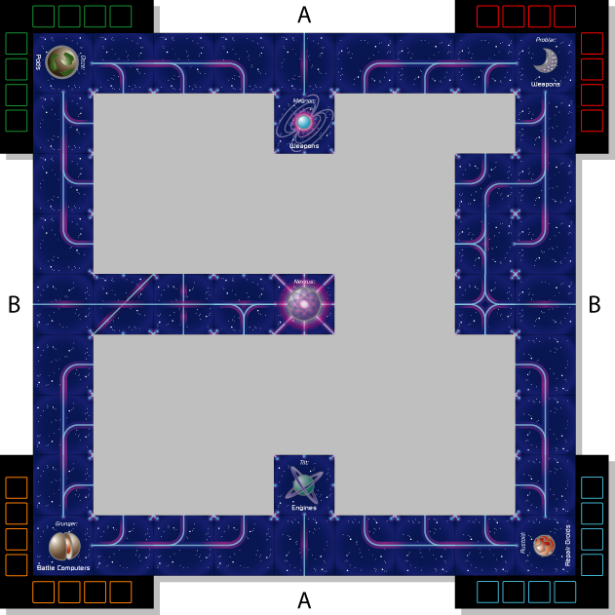
A much more interesting Hyperline is the one that connects the Home planet Problar (upper right corner) to Nexxus (in the middle) through the loop line marked “B”.

Ship Components
As the game progresses you will add more components onto your Starship. In Hyperline bigger is always better! Each component has its own special ability. In some cases these abilities may contradict a general rule. In that case, the component’s ability always takes precedent over a general rule.
Components that are damaged lose all special abilities.

Bridge
You start the game with 1 Bridge and you may not buy another. The back of the Bridge must be connected to a Pod and your Bridge must face forward. You need an undamaged Bridge to perform the Research command.

Bridge Upgrades
1 of each per ship. These 3 components are considered part of your Bridge. If your Bridge is damaged all the upgrades go offline and cannot be used. Upgrades automatically come back online when your Bridge is repaired.
Repair Droid
After you perform the Repair command you may issue an additional non-repair command on the same turn.
You may not use a Repair Droid when doing a full repair on your Home planet. You may not use a Repair Droid while in the Nexxus sector. (The Hyper-radiation interferes with their Positronic brain systems.)
Hyperline Computer
You may use diagonal Hyperpoints for scanning, moving and firing plasma torpedoes.
Battle Computer
A Battle Computer gives you 3 bonuses:
- Combat is no longer simultaneous. During each Combat Round the enemy takes your damage first, and then gives damage (if still able). If both players have a Battle Computer then they cancel each other out.
- You may run away from combat before the first Combat Round begins. You lose this ability if your opponent also has a Battle Computer.
- Treat Asteroid sectors as if they were empty.
Pods
All Pods must be attached to another Pod or to the back of your Bridge.
Carrier Pod
Each Carrier Pod can carry 1 fighter. When a fighter is loaded onto your Starship you place a Fightercraft token on top of the Carrier Pod. When the fighter is unloaded it is placed on the board in the appropriate sector and is considered to be “on patrol”.
Battle Pod
Weapons, Scanners, Shields and Turret Pods attached directly to your Battle Pod gain special bonuses.
Turret Pod
Must be attached to another Pod or to the back of your Bridge.
You may attach any component to the horizontal and vertical edges of the Turret Pod, but you may only attach a Weapon, Scanner or Shield to the “turret” (the diagonal edge).
Components on the turret face in two directions simultaneously. If the Turret Pod is damaged then components on the turret are considered to be facing to the side, not to the front or back.
Battle Pod Bonus: Treat the turret as if it were a Battle Pod. Components on the horizontal and vertical edges do not get any bonuses.
Engines
Combat Engine
Must be connected to a Pod or to another Combat Engine along the side. Combat Engines must face the rear.
Each Combat Engine gives your ship 1 point of speed.
If your ship’s speed is 1 point higher than your opponent’s speed then you may add or subtract 1 from the result of your direction die roll. For instance, a roll of 1 could be converted into either a 2 or a 4.
If your speed is 2 or more points higher than your opponent’s then you do not need to roll a direction die during combat. You may pick any facing you wish.
Hyperline Engine
Must be connected to a Pod or your Bridge along the side and face toward the rear of your ship.
Each Hyperline Engine gives your ship 1 bonus move.
After you perform the Move command you may immediately make one additonal bonus move for each Hyperline Engine. (See Bonus Moves, page 8.)
Rip Engine
Must be connected to a Pod or your Bridge.
If you have a Rip Engine you may Ripshift instead of Jumping. Each Rip Engine can convert one Jump per turn.
Rip Engines do not give you a movement bonus by themselves. They can only convert a Jump. If you don’t have the ability to Jump then you can’t Ripshift, no matter how many Rip Engines you have attached to your ship.
A Ripshift takes you directly to either a Rip sector or to your Home planet.
Weapons
Must be connected to a Pod or your Bridge. All of the weapons do 1 point of damage when facing the enemy during the Give Damage step of a Combat Round.
Laser Cannon
Battle Pod Bonus: Does 2 points of damage instead of 1.
Plasma Launcher
Battle Pod Bonus: If there are no enemies in your sector you may fire one long-range plasma torpedo during the Combat phase. You may target either a Starship or a Pirate. You may not target Starships at a Home planet.
You must have a Hyperline connection with your target. If a sector is adjacent, but not connected, then you may not fire into it.
The plasma torpedo has a speed of 0 and does 1 damage for each Battle Pod-enhanced Plasma Launcher attached to your Starship.

Focus Beam
Battle Pod Bonus: When a Focus Beam hits you may specify one of your enemy’s components as a target. Do this during the Give Damage step. During the Take Damage step your opponent must assign damage to the targeted component.
All target components must be chosen before any damage occurs. You may not target a component if it is blocked by another functional component. You may not target a fighter.
If your opponent has an Interphasic Shield facing your Focus Beam then you can only target his Interphasic Shield, no matter how many Focus Beams you have. It is considered to stretch across the entire quadrant and won’t collapse until the Take Damage step.
Shields
Except for Starships on Nexxus, all damaged shields are automatically restored during the Restore Shields phase.
Battle Pod Bonus: Damaged shields are automatically restored at the end of each Combat Round (except when on Nexxus).

Hardpoint Shield
Must be attached to a Pod or your Bridge.
Each Combat Round, during the Take Damage step, you can ignore the first hit to this shield’s front. The Hardpoint Shield does not get this bonus if it is hit from the side or from behind.
Interphasic (“Floating”) Shield

Unlike other components, an Interphasic Shield does not attach directly to your ship. Instead it “floats” near one side of your ship and stretches across to protect an entire quadrant. You may have multiple shields stacked in the same quadrant.
It can take damage from the sides (the small edges).

Transfer Shield
Must be attached to a Pod or your Bridge.
At any time you may voluntarily damage this shield to restore any other shield on your ship.
Scanners
Must be attached to a Pod or your Bridge.
During the Scan phase select an empty sector at the end of a Hyperline connection. Draw a tile from the Hyperline stack and place it into the selected sector.
Battle Pod Bonus: After completing the Research command you may perform a tight scan. If you choose to do this then take 1 point of damage. If your Bridge is still functional then roll the direction die. You collect 1 additional research point if at least one boosted scanner is facing in that direction.
Planetary Scanner
Instead of a normal scan you may secretly look at a tile from the Planet stack and then place it facedown in any valid sector. Turn the tile face up when any Starship moves into that sector.
Disrupting Scanner
Instead of a normal scan you may choose to rotate any Hyperline tile along a connected path.
Quantum Scanner
When you scan you may secretly look at the top 3 Hyperline tiles. Choose one to place on the board and return the other two back to the top of the Hyperline stack in any order.
Definitions

Connected Sectors
Two sectors are considered connected if you could travel from one sector to the other with just one Jump.
- It is possible to have one-way connections. This occurs when the Hyperline terminates at a diagonal Hyperpoint.
- A Hyperline Computer allows you to connect two sectors together using diagonal Hyperpoints.
- When Scanning you are allowed to connect to an unexplored sector at the end of an uncompleted Hyperline.

Adjacent Sectors
A sector is considered adjacent when it shares a common edge with another sector.
- Diagonal sectors are never adjacent, even if you have a Hyperline Computer.
- It is possible for sectors to be adjacent, yet not be connected.
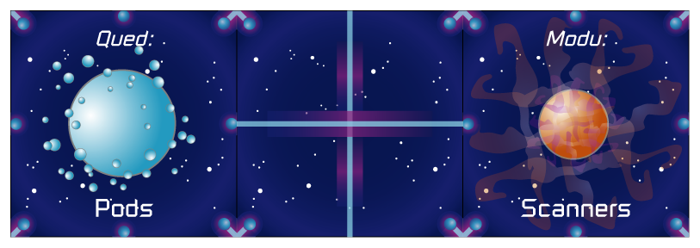
In this example the planet Qued is adjacent to the middle sector, but is not connected to it. There is no way to get from Qued to the middle sector in one Jump. To get there you would have to Step.

Explored Sector
A sector with a tile placed in it.

Unexplored Sector
A sector that does not yet have a tile placed in it.
Customer Support
If you have questions about these rules please contact Steve Librande at (408) 836-5905 or email gamedesign@pacbell.net
Credits
Design, Art and Rulebook: Steve Librande
Play Testers: Dylan, Jordan and Toby Librande. Mike Dashow, Jeff Gates, Mike Huang, Cory Rogers, Bill Roper, Tod Semple, Tyler Thompson.

Hyperline is copyright ©2002-2004 Stonetronix Designs, Inc. All rights reserved.

